Test Plan

Kaichen Le KLE11

The Chessboard looks like this by default after running the Main in GUI.

Rook Horse Bishop Queen King Bishop Horse Rook

Pawn Pawn Pawn Pawn Pawn Pawn Pawn Pawn

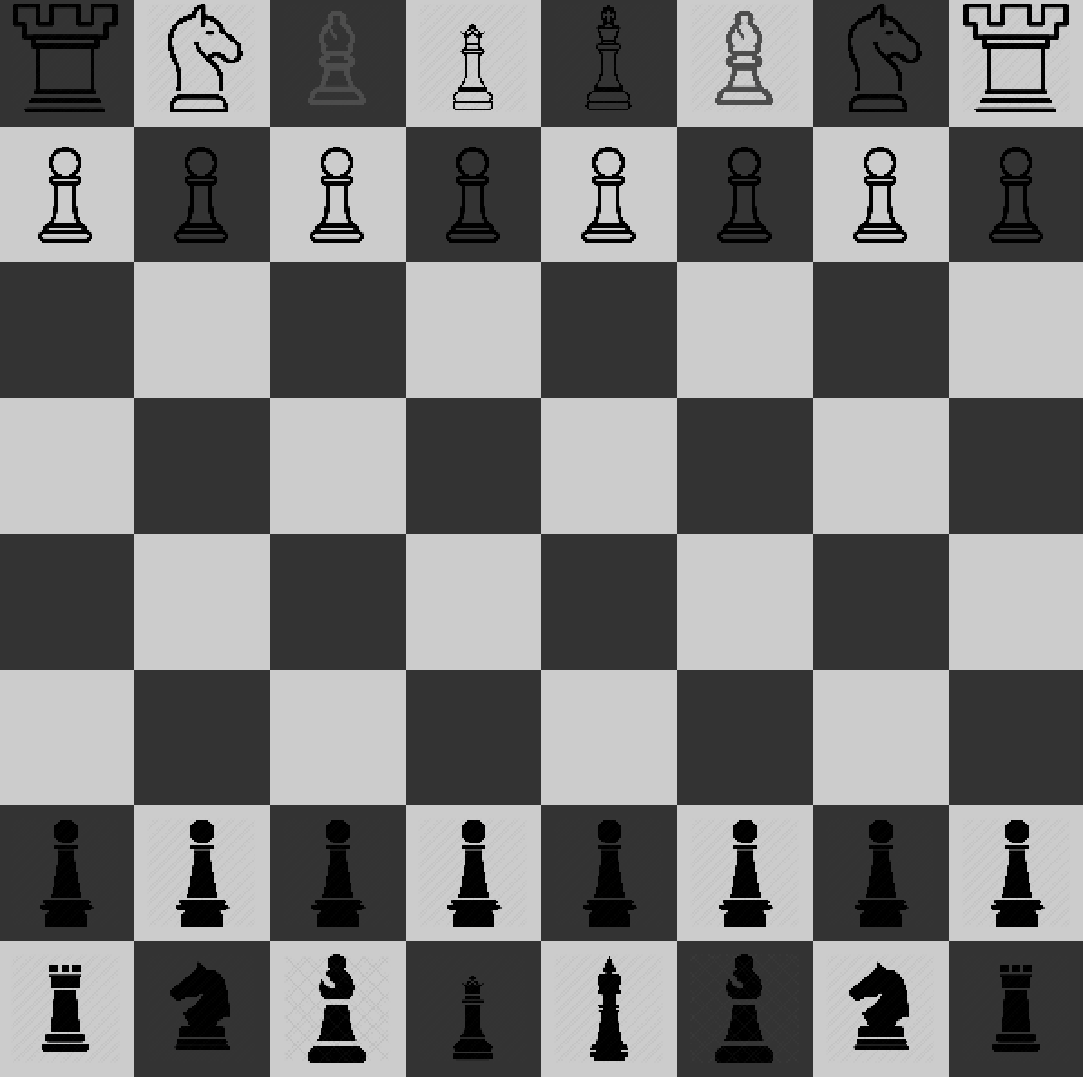

Pawn Pawn Pawn Pawn Pawn Pawn Pawn Pawn

Rook Horse Bishop Queen King Bishop Horse Rook

It will prompt user to enter name for both users.

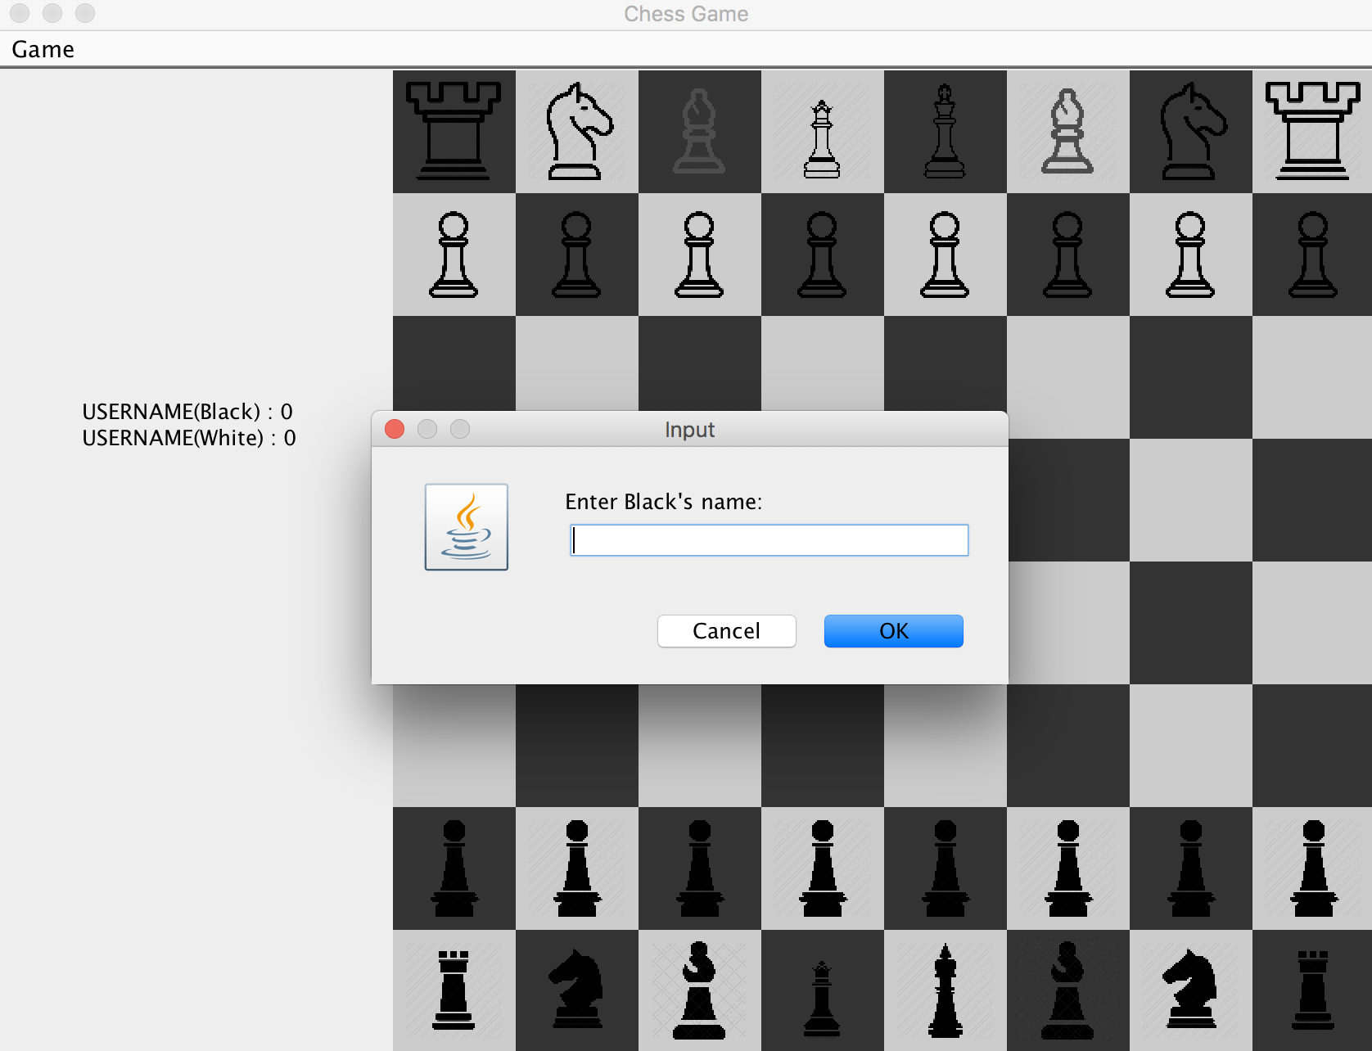

After entering the name, the name will be appear on the left split of the window:

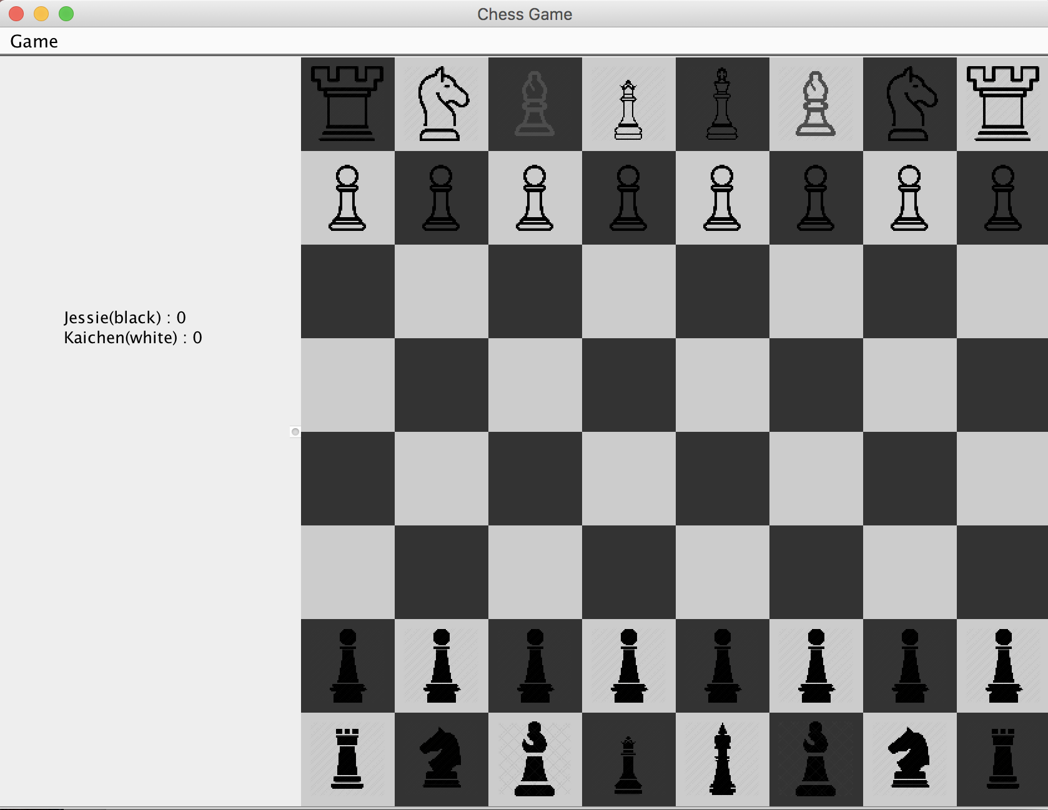

By default it is standard chess board, but user can switch to the custom one by clicking on Menu => custom game

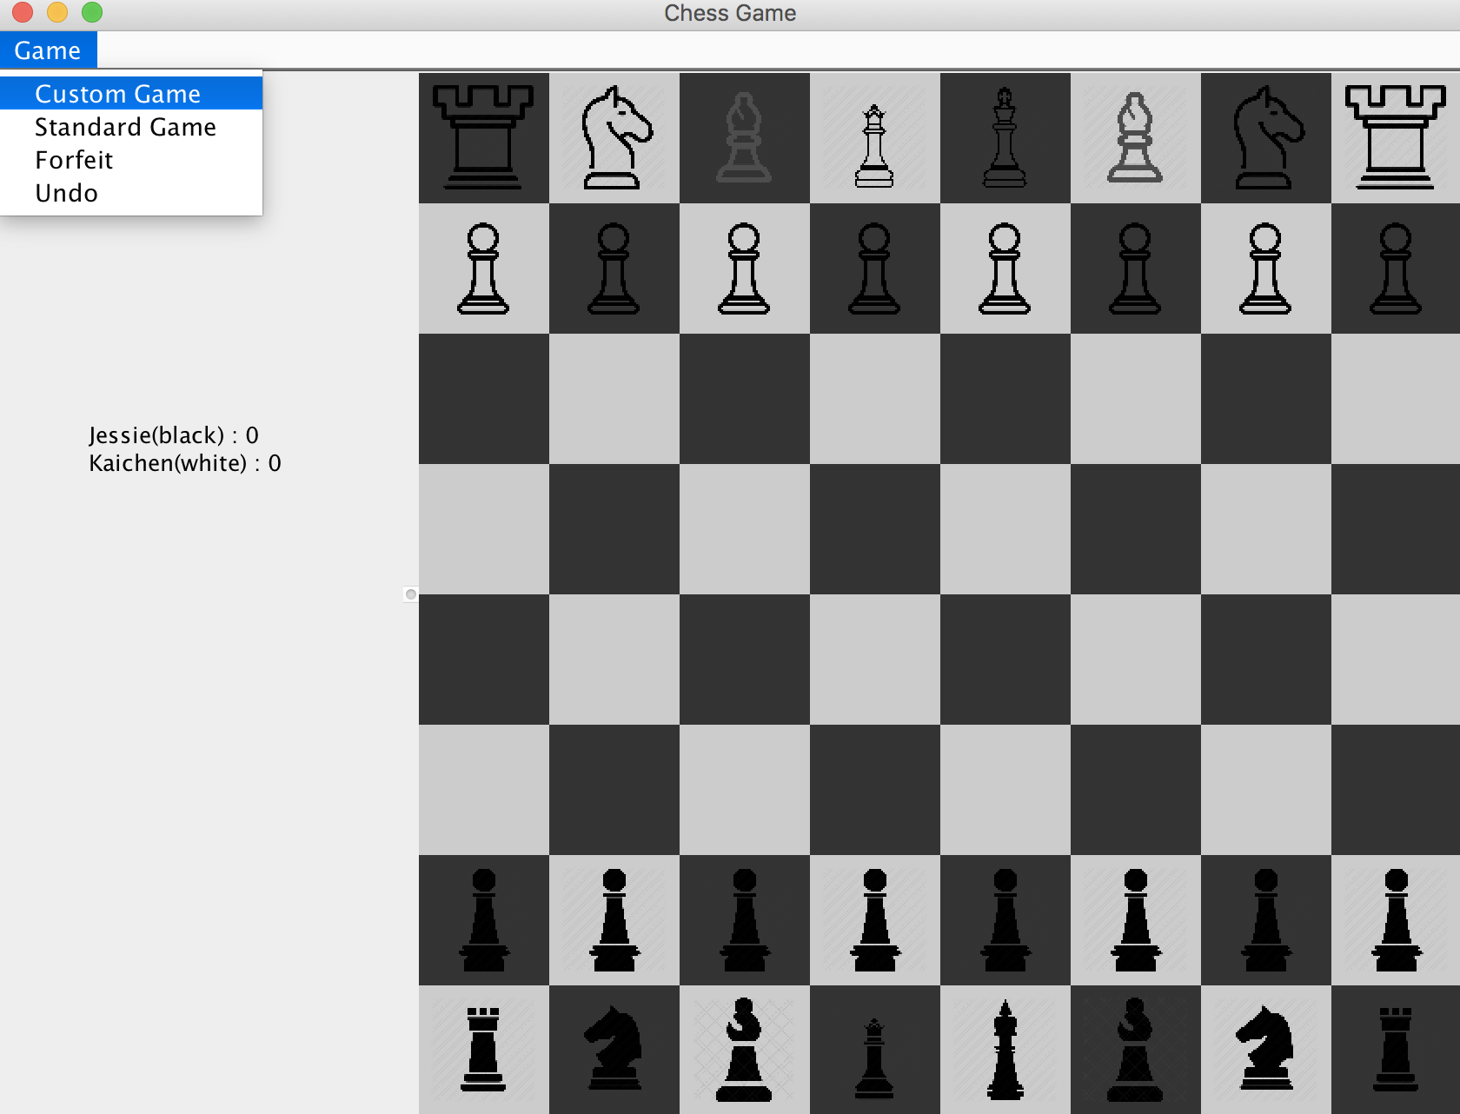

Custom game add to chess pieces: ox and crab. (Ox only move vertically while Crab only move horizontally )

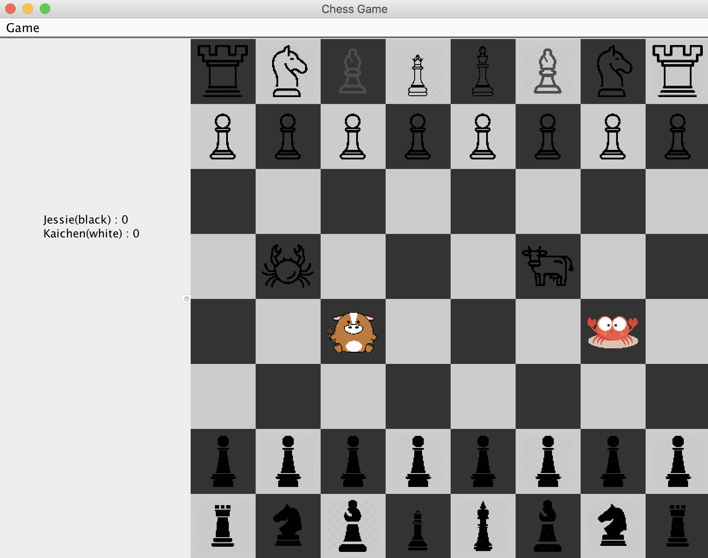

User can click forfeit if they don’t want to play this round any more.

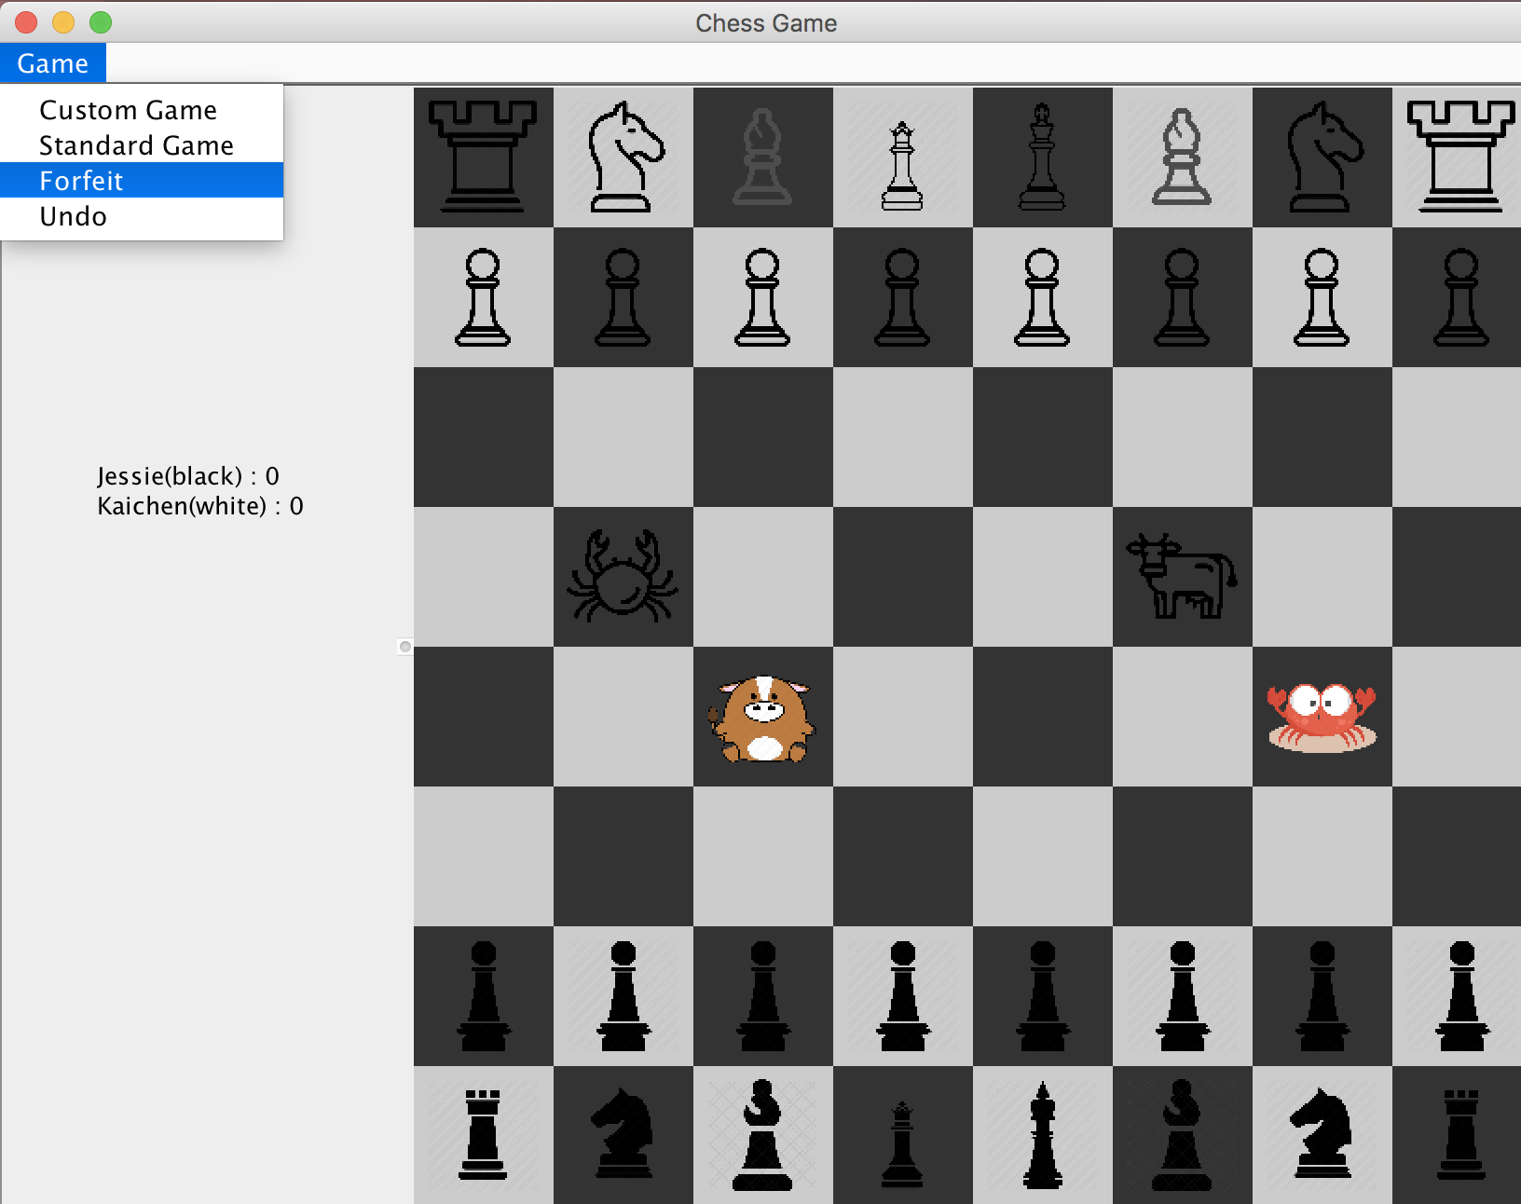

A message dialog will popup and confirm with the user.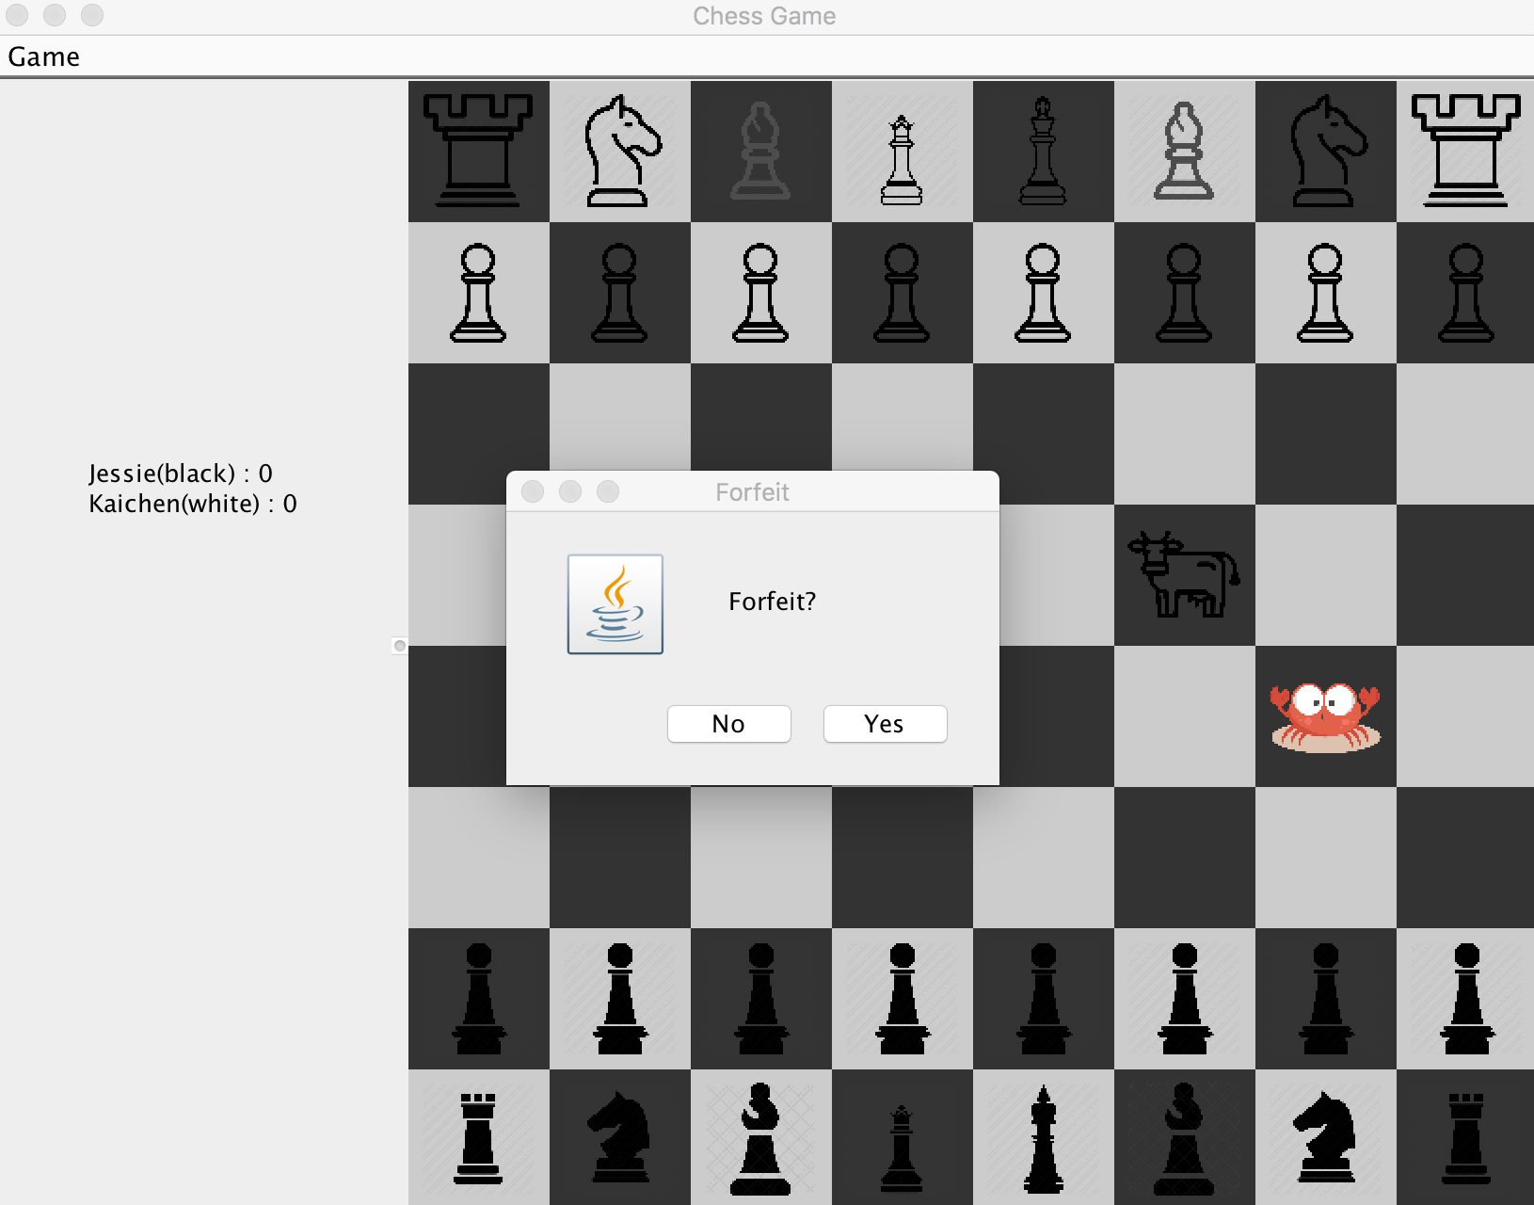

After clicking yes, the score will be updated and the game will be restarted:

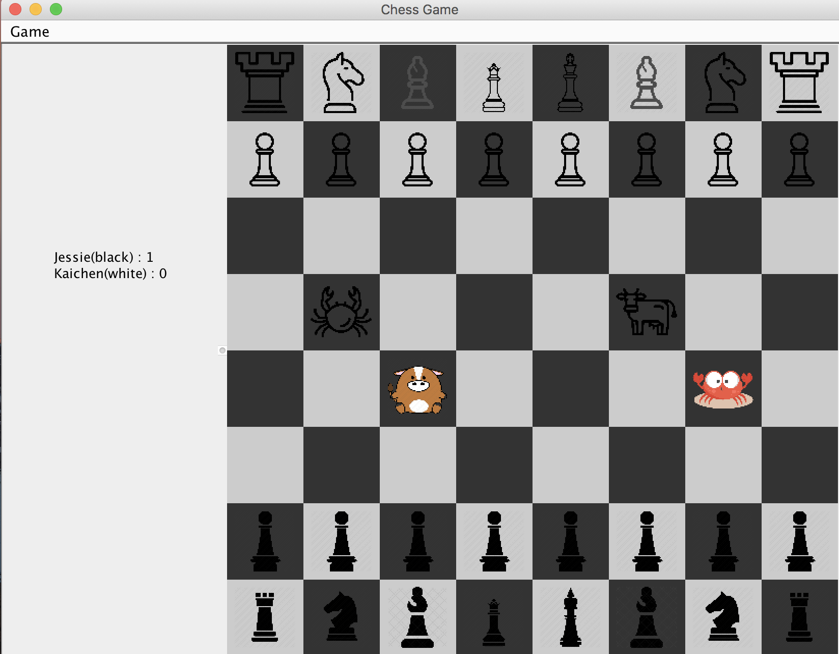

The score will remain if the same user play the game even with different mode:

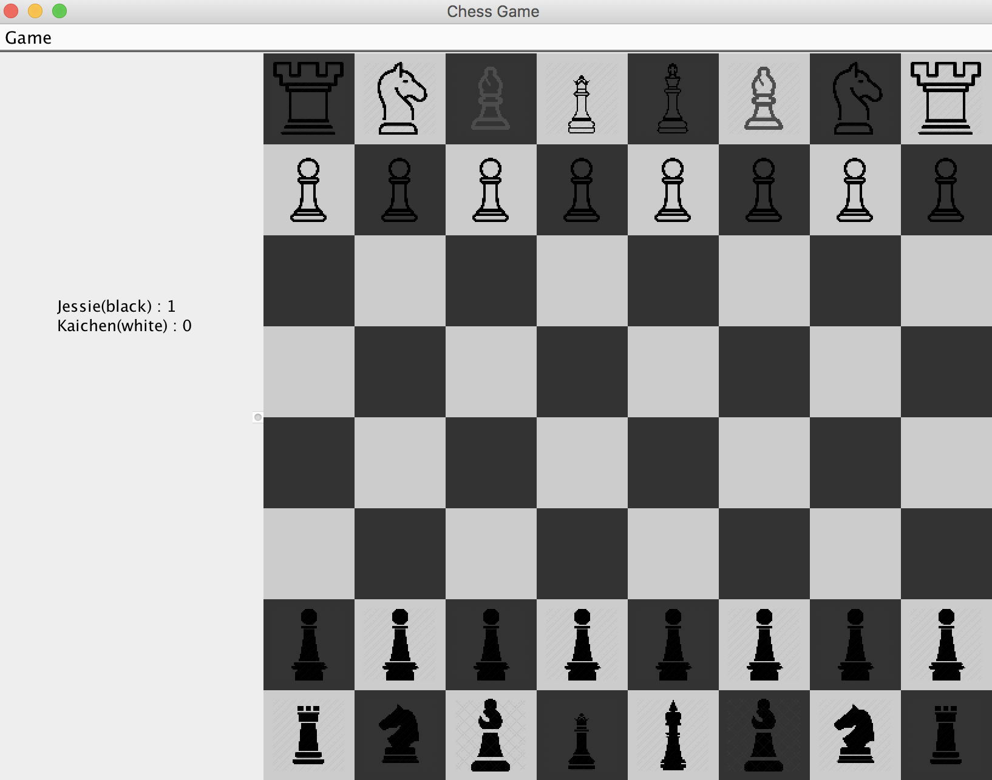

The background color will be changed if the chess is selected:

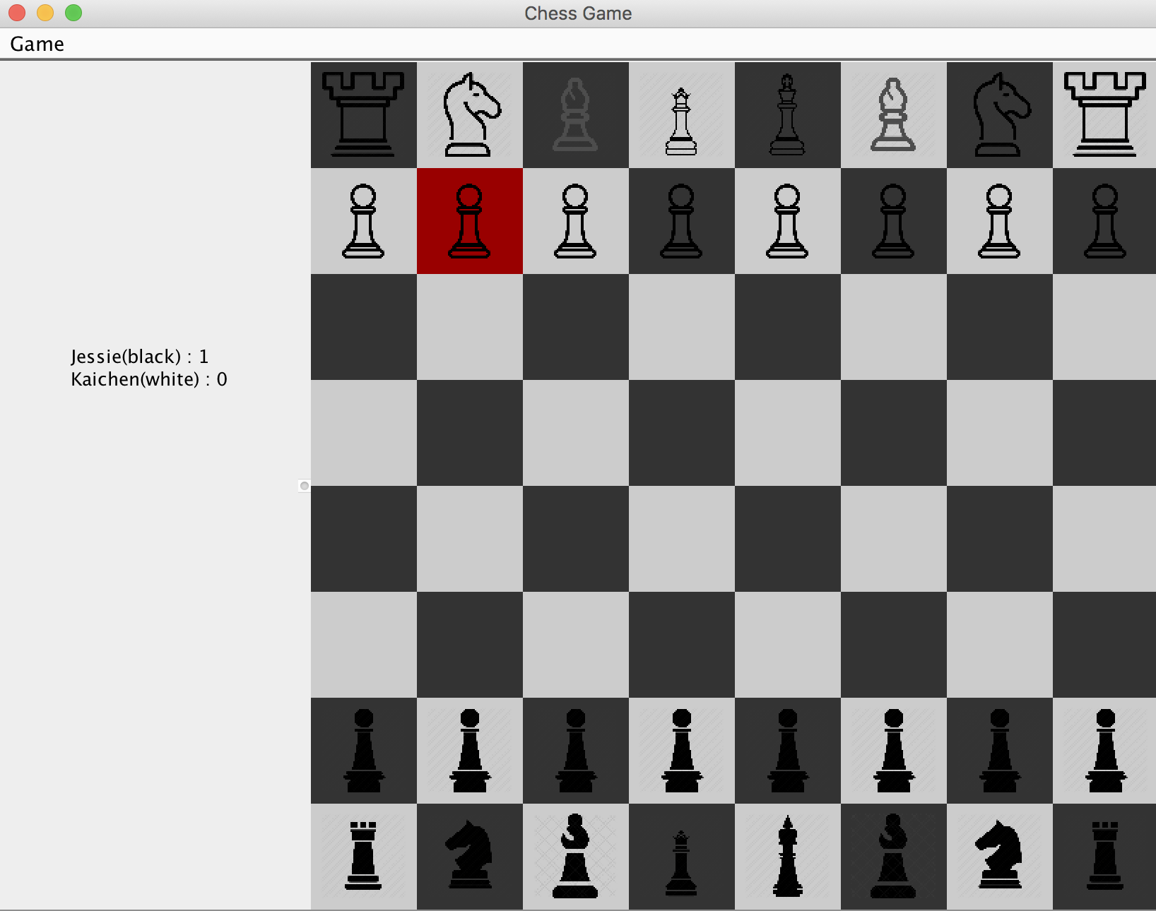

If user try to put the chess as an invalid position, an alarm messeage will pop up and the move will not be processed:

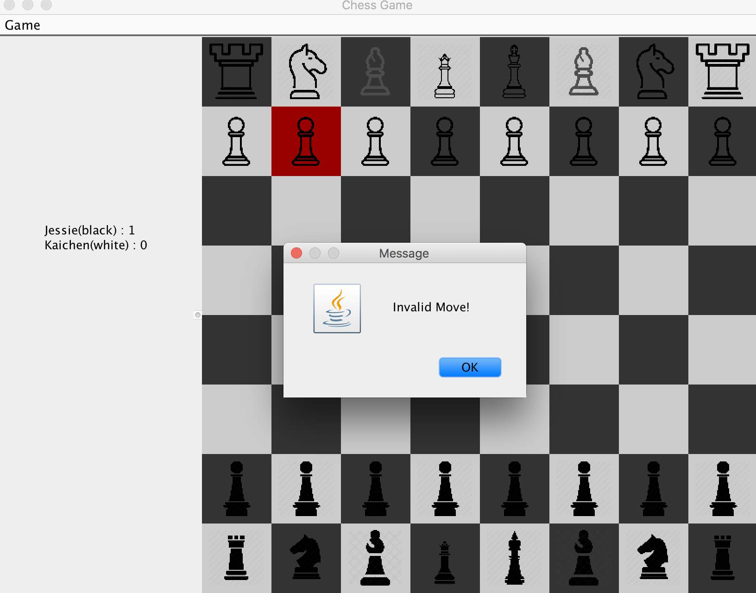

If user try to move the chess when it is not their turn a warning message will also pop up:

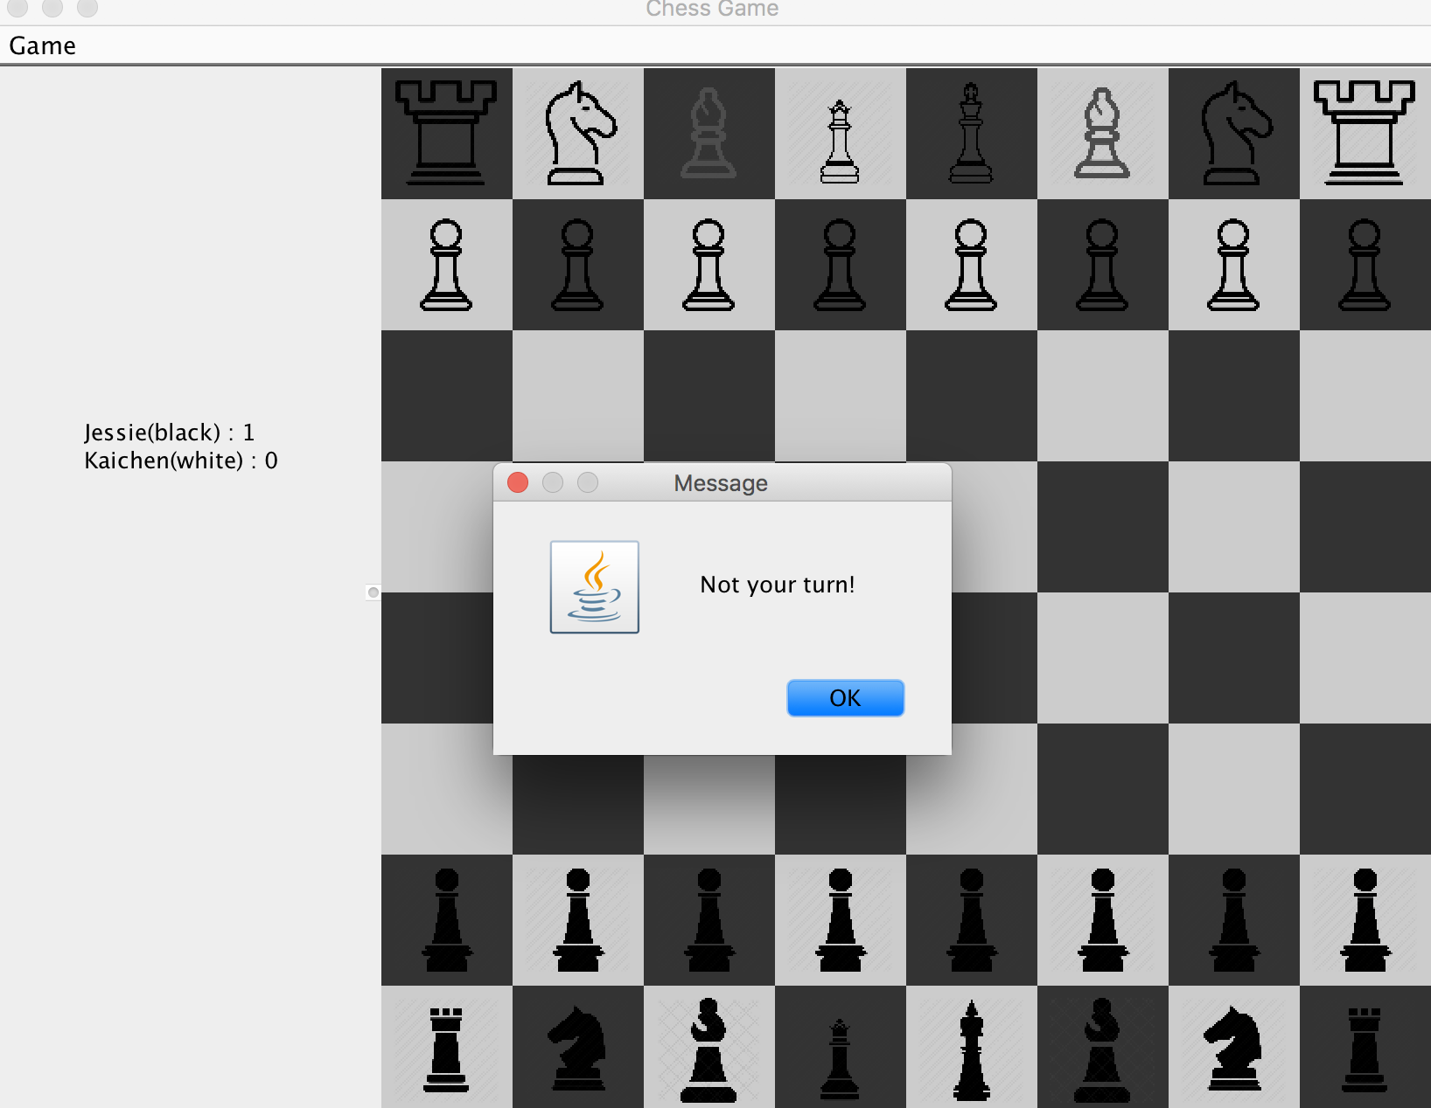

User can undo by clicking Menu=>undo

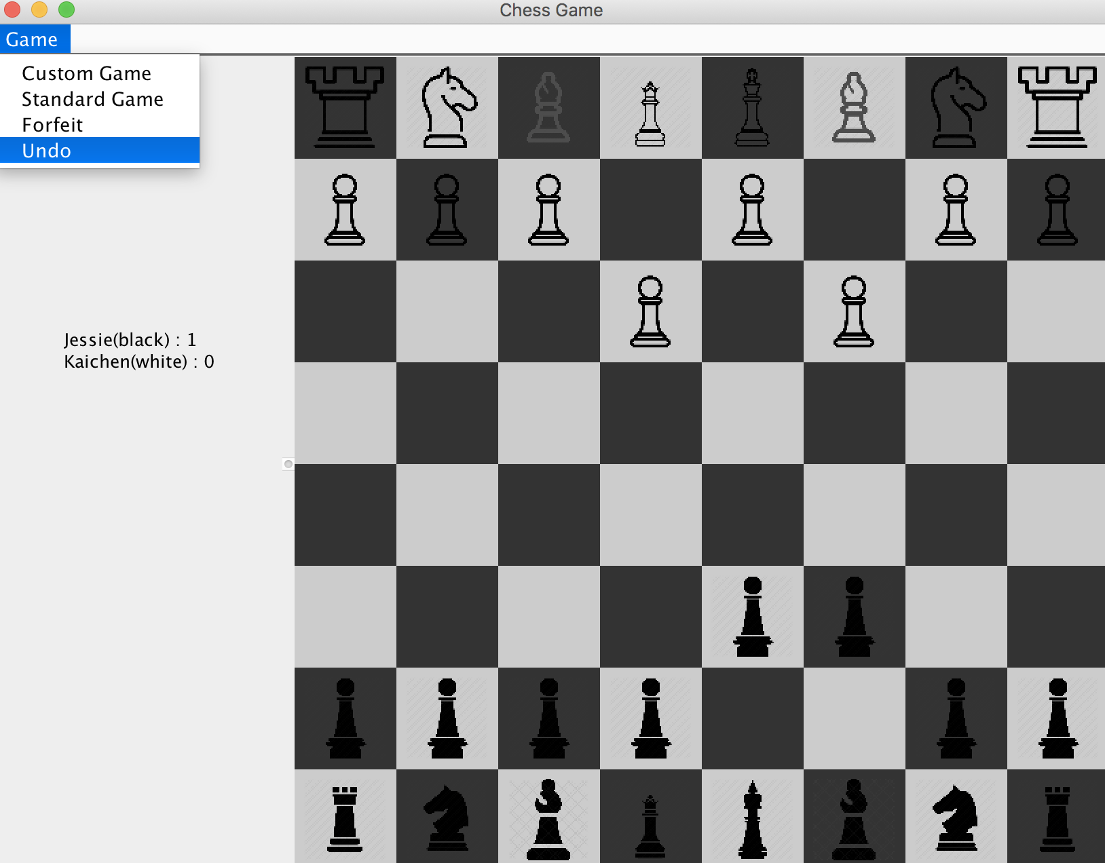

Users can undo the game if both of them are agree with it because undo will undo one step for both users, but user can undo multiple times as long as they have steps to undo:

Undo first time:

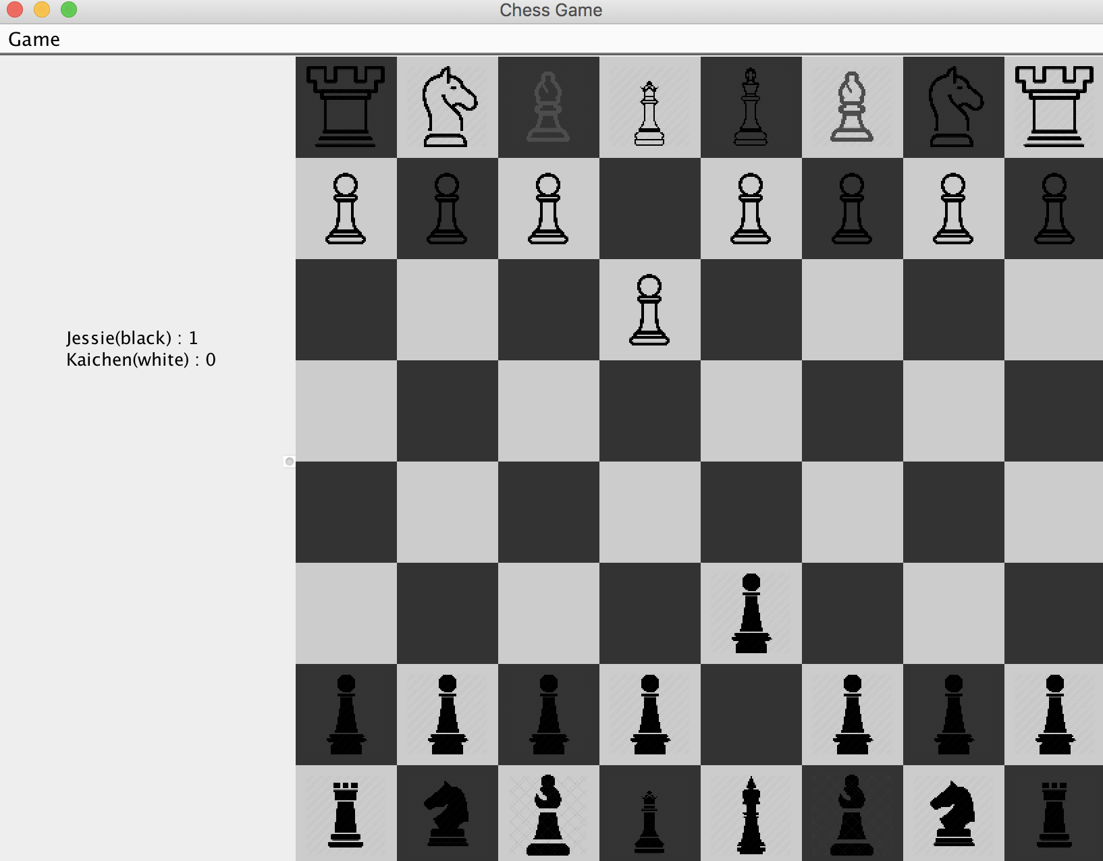

Undo second time:

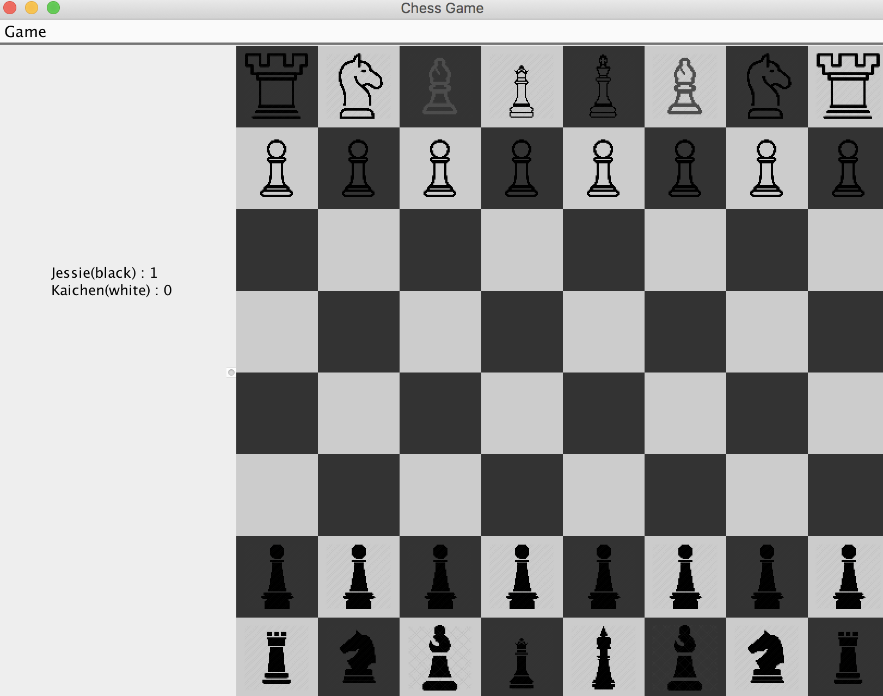

if there is nothing to undo, an alarm dialog will pop up:

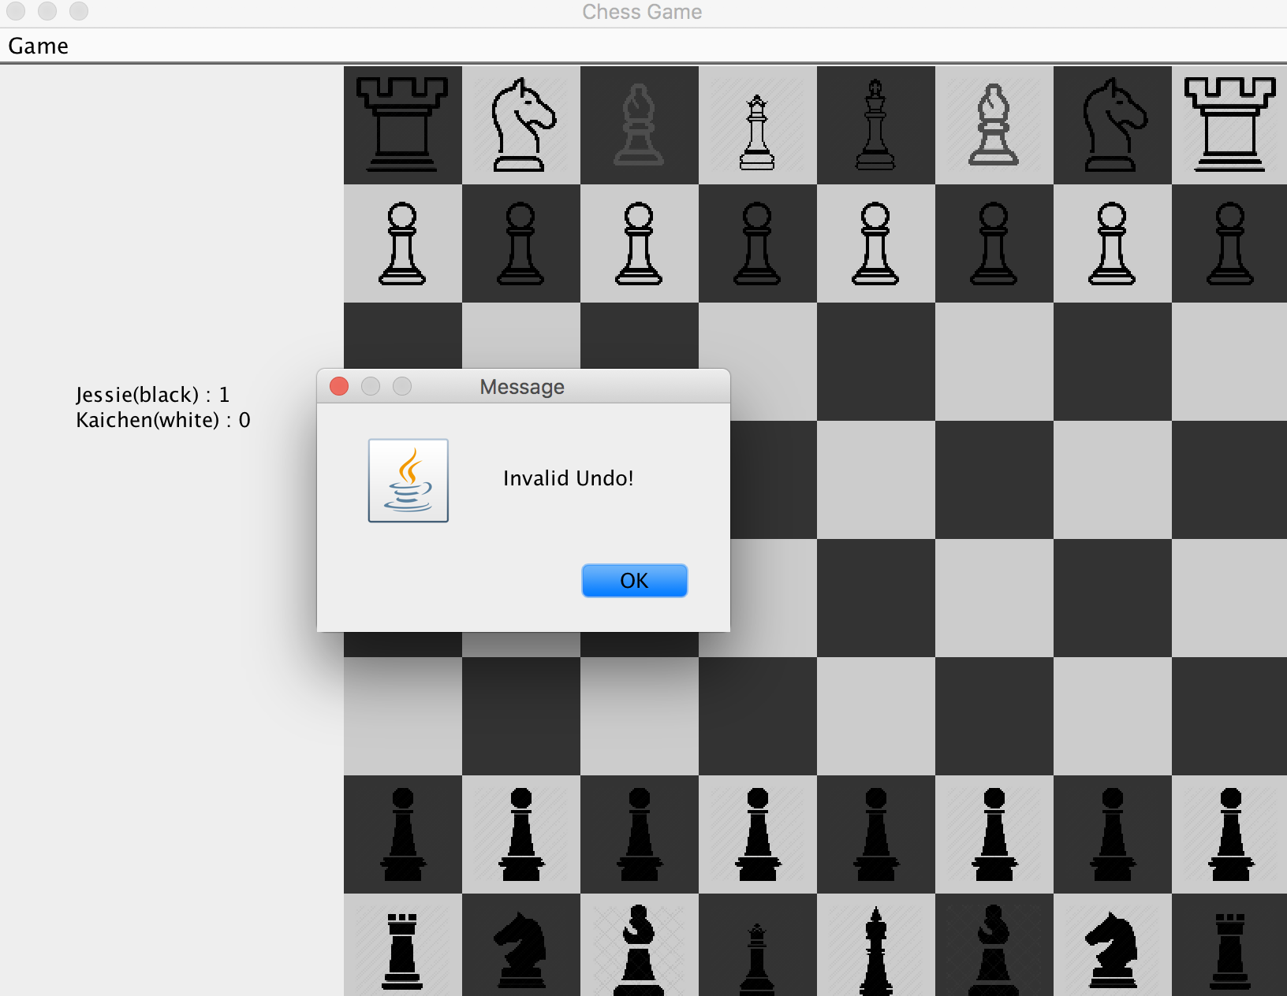

When there is a checkmate:

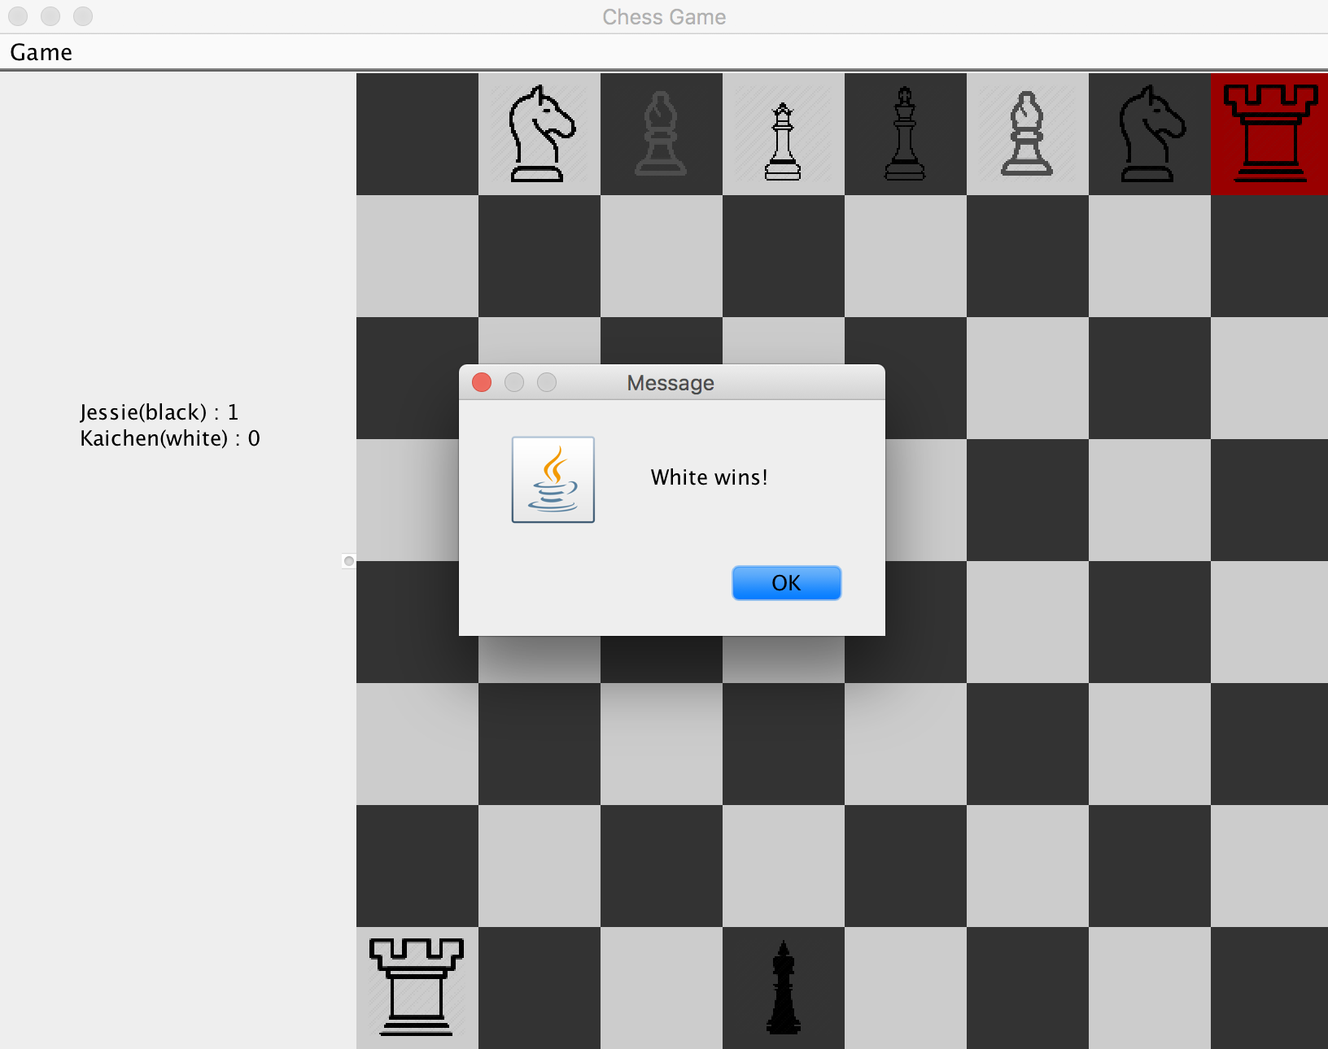

When there is a stalemate:

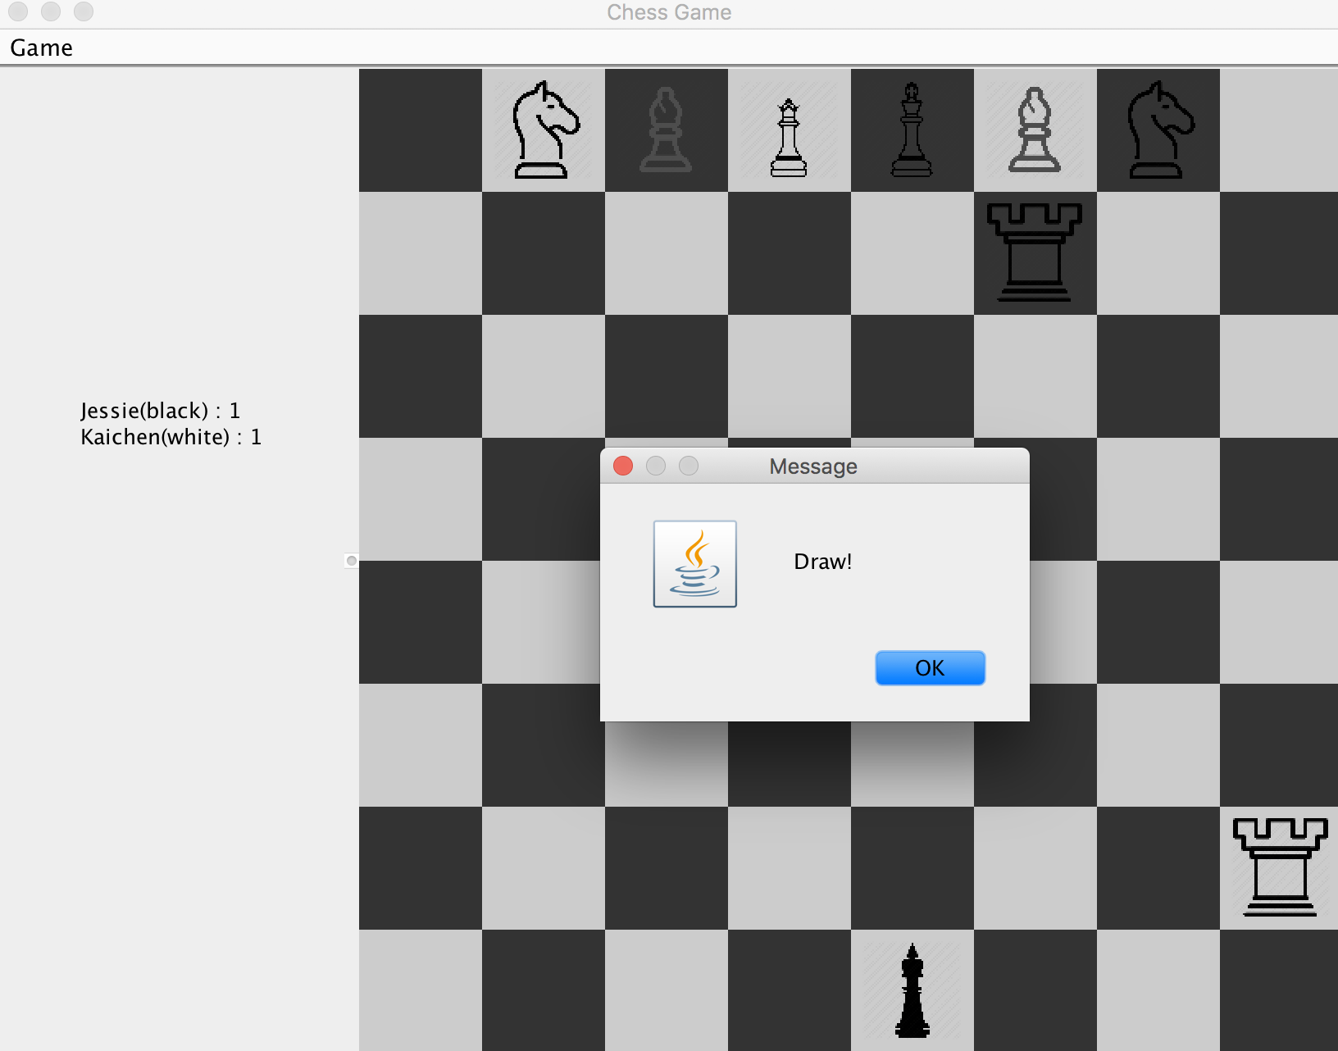

If there is a draw both player get score:

